**S3 CROSS ACCOUNT REPLICATION:**

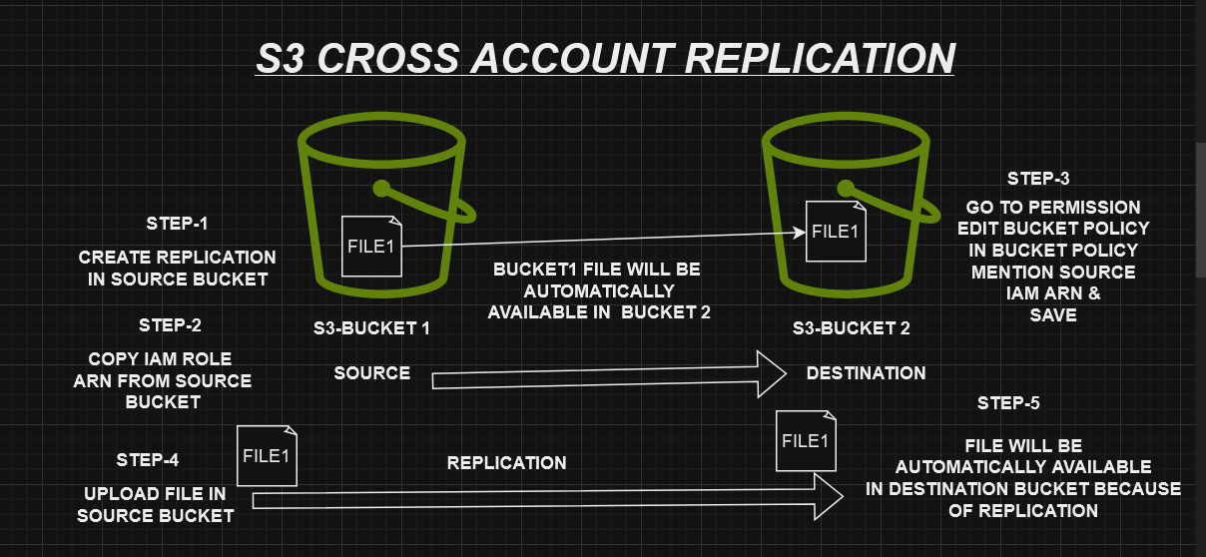

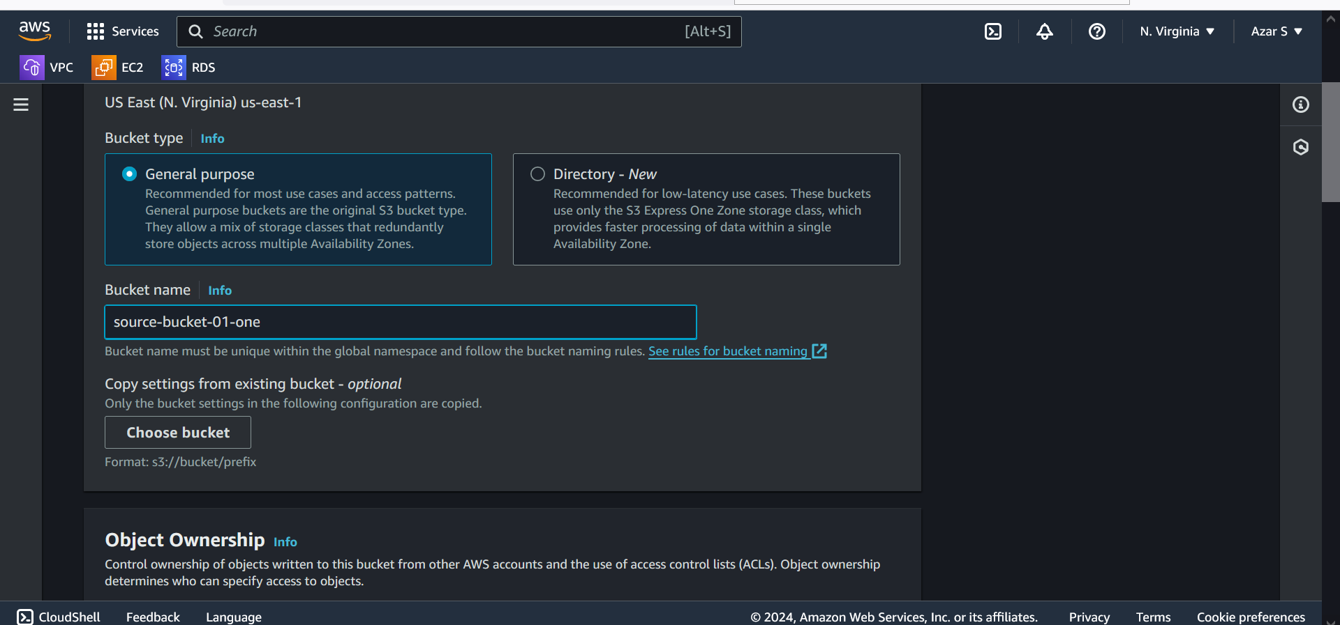

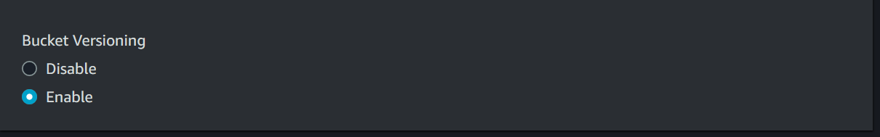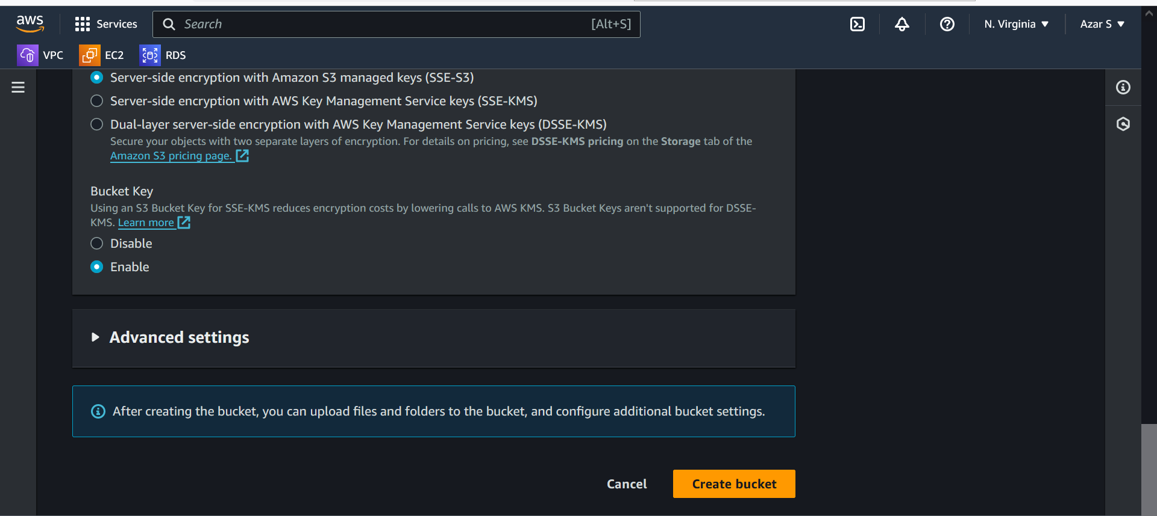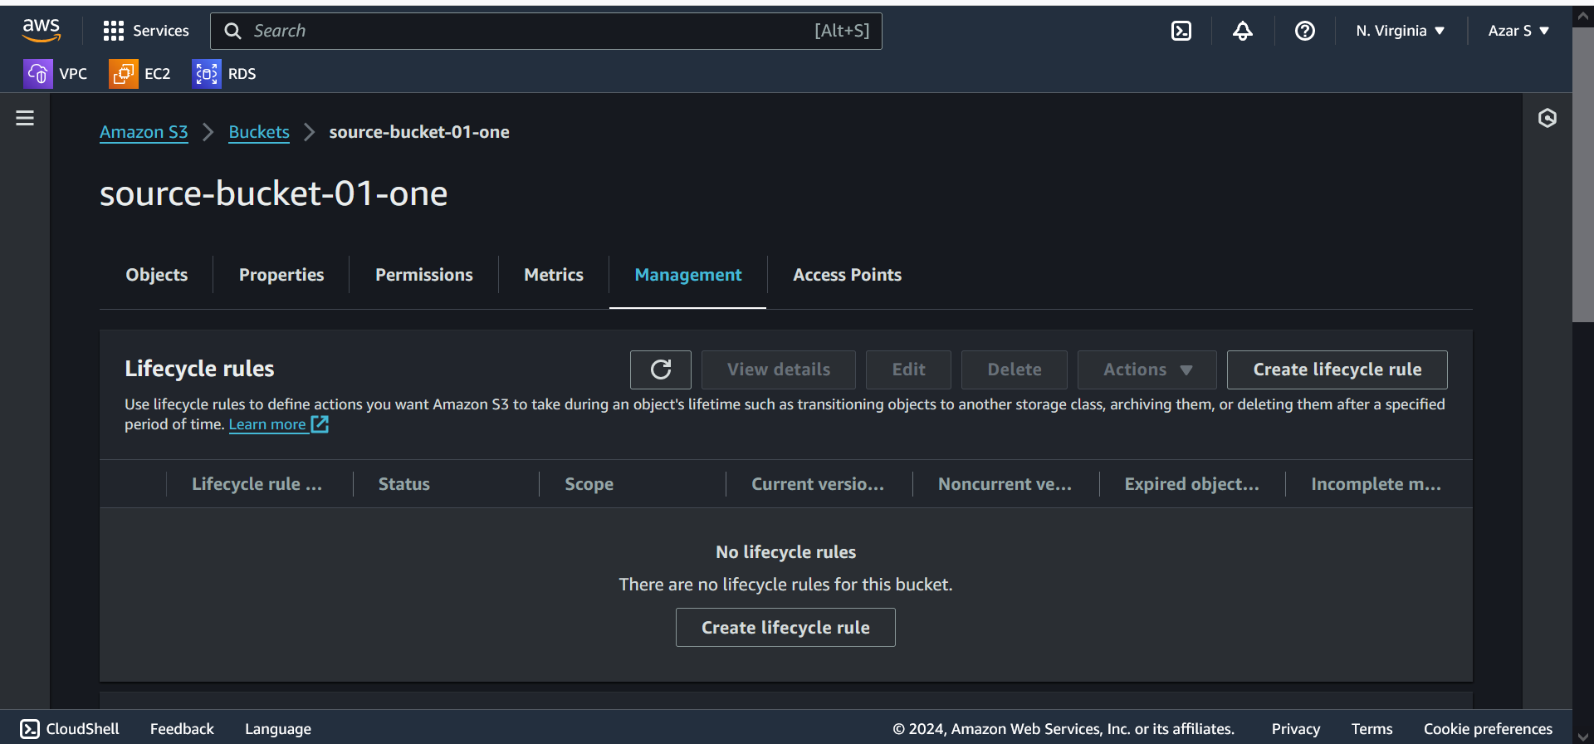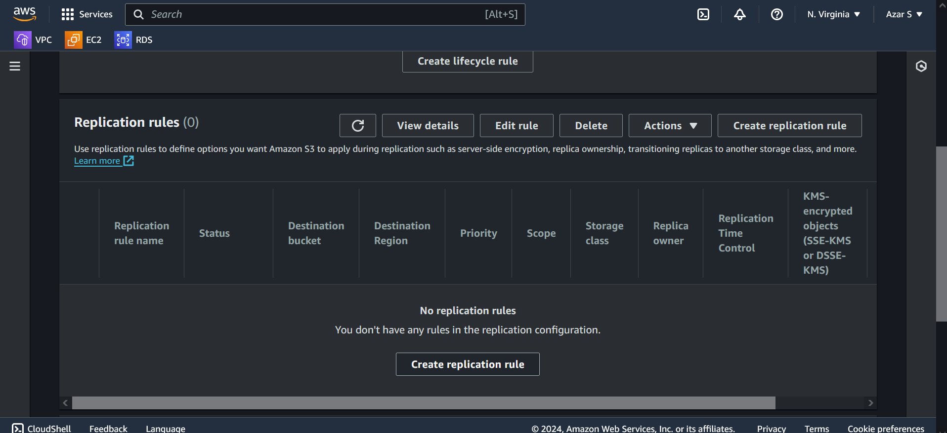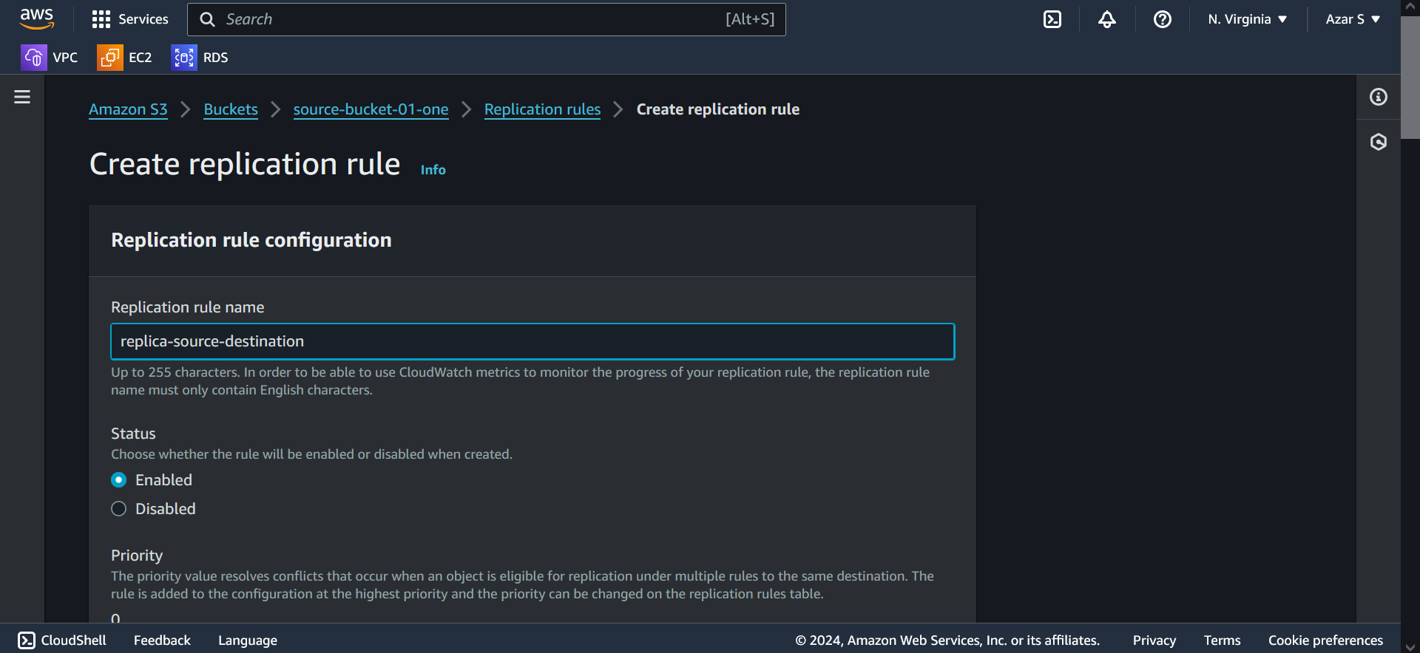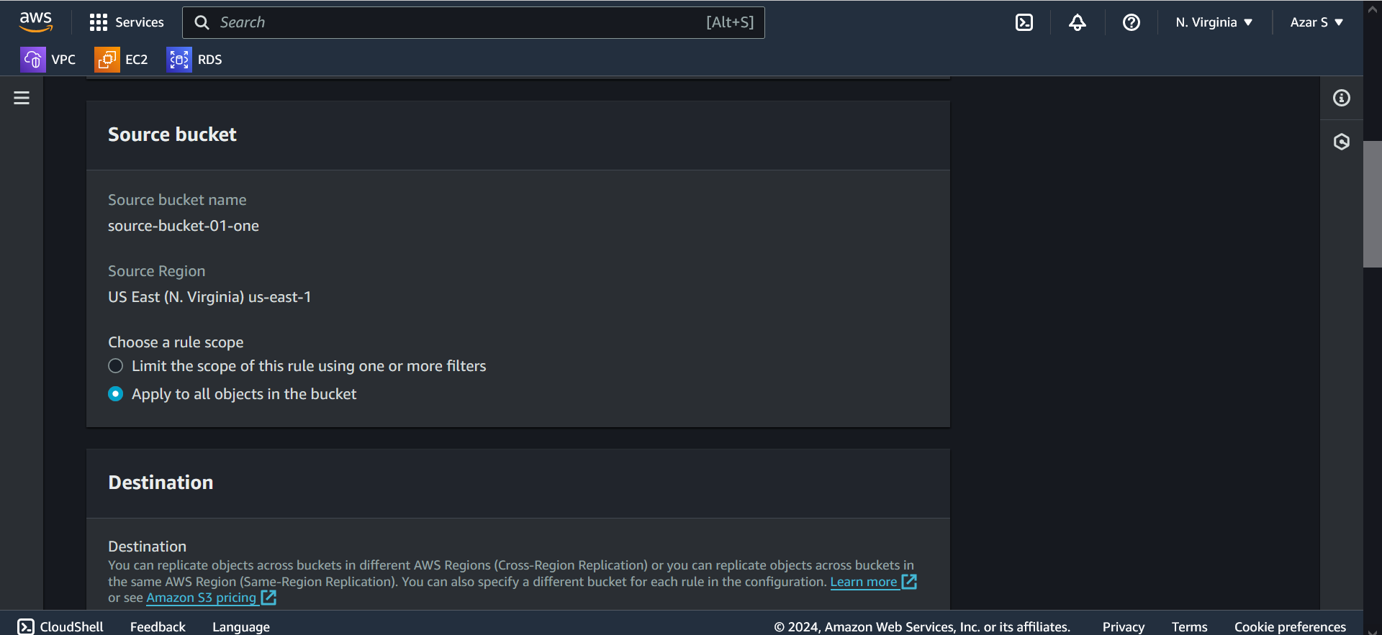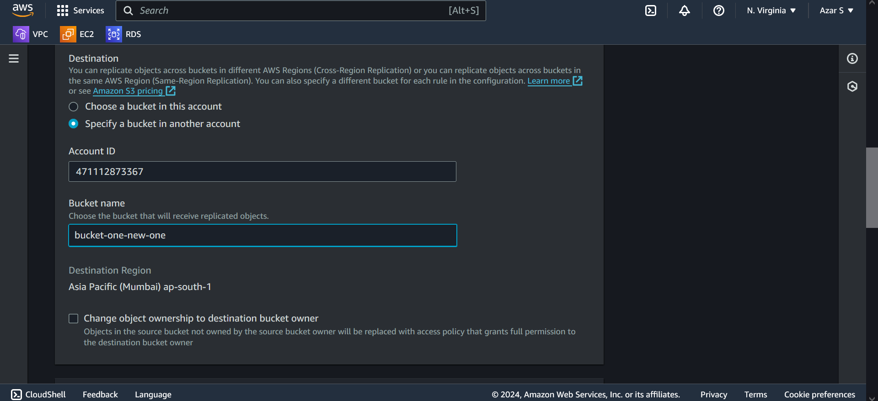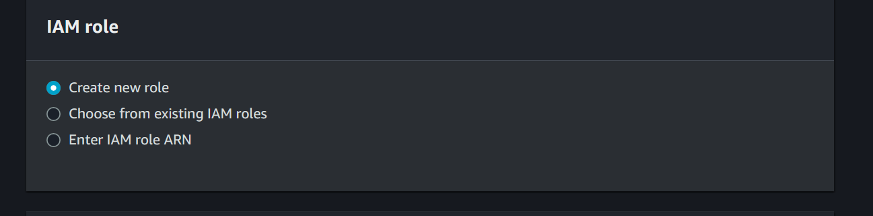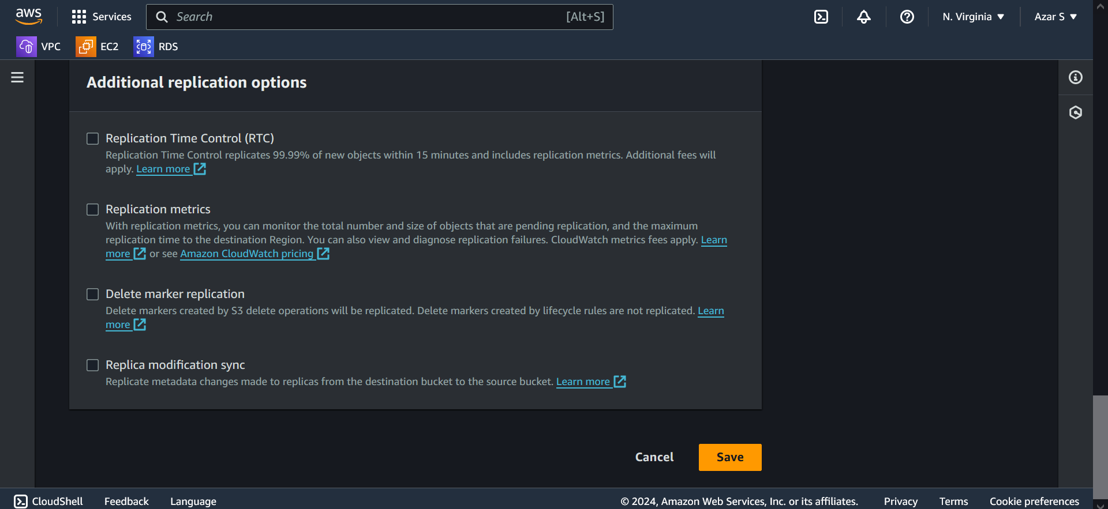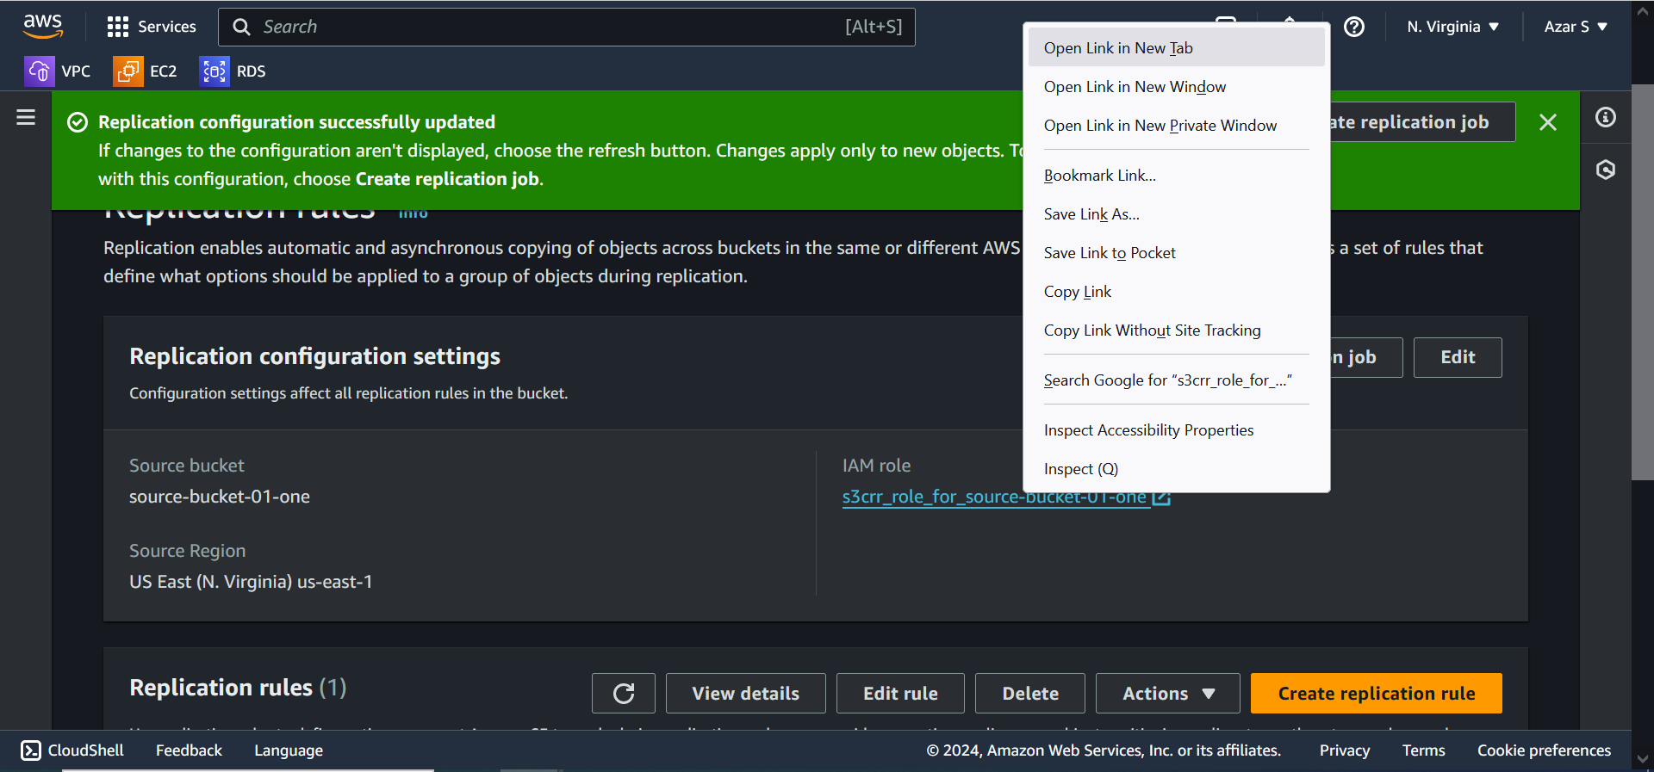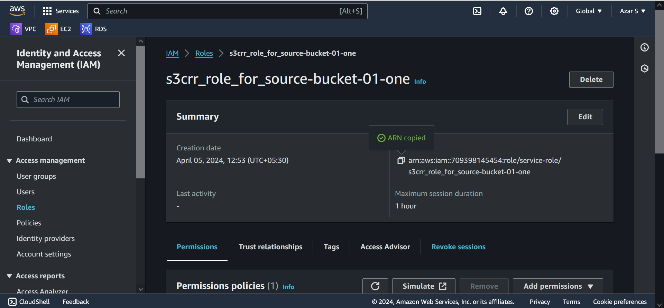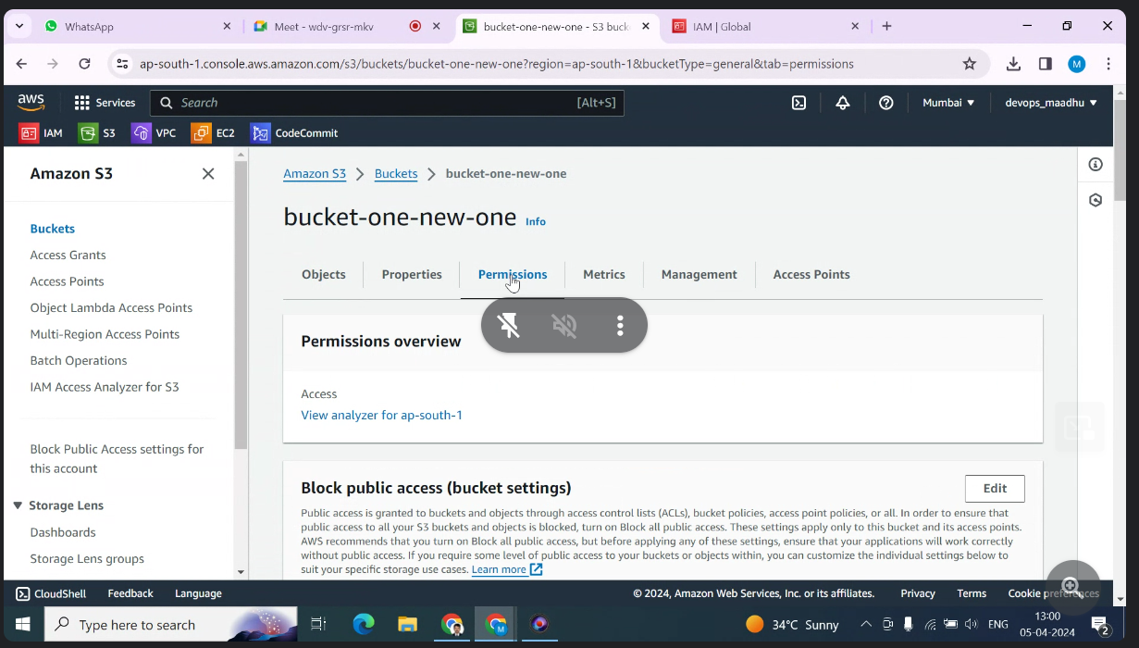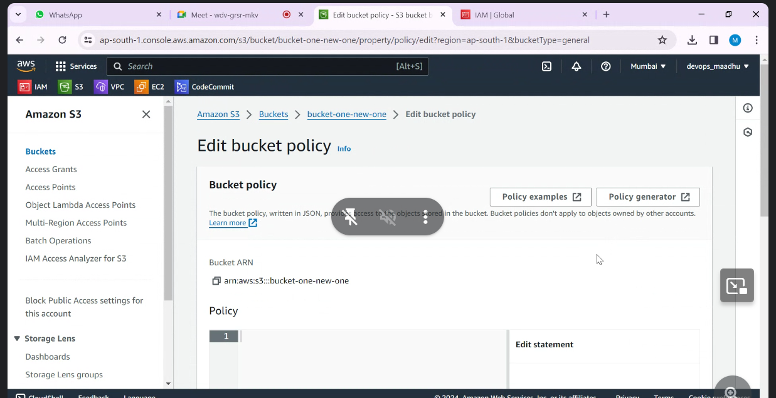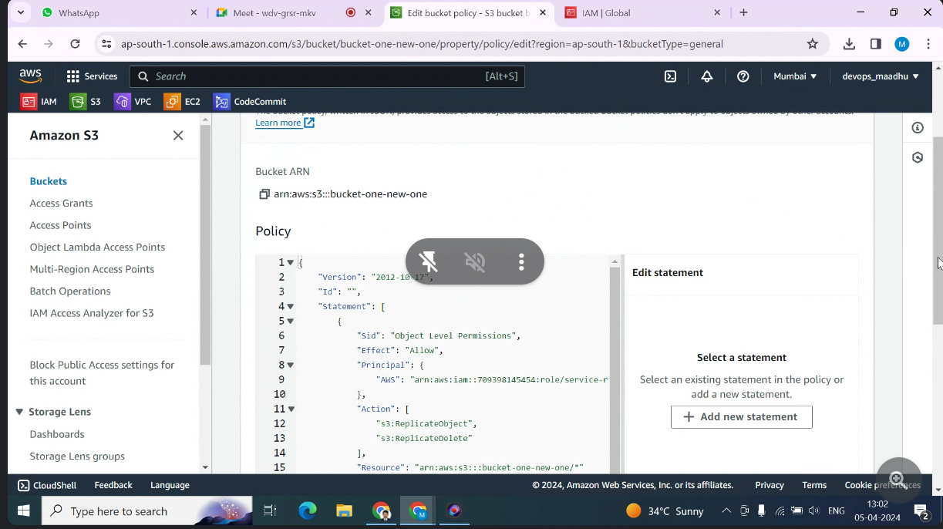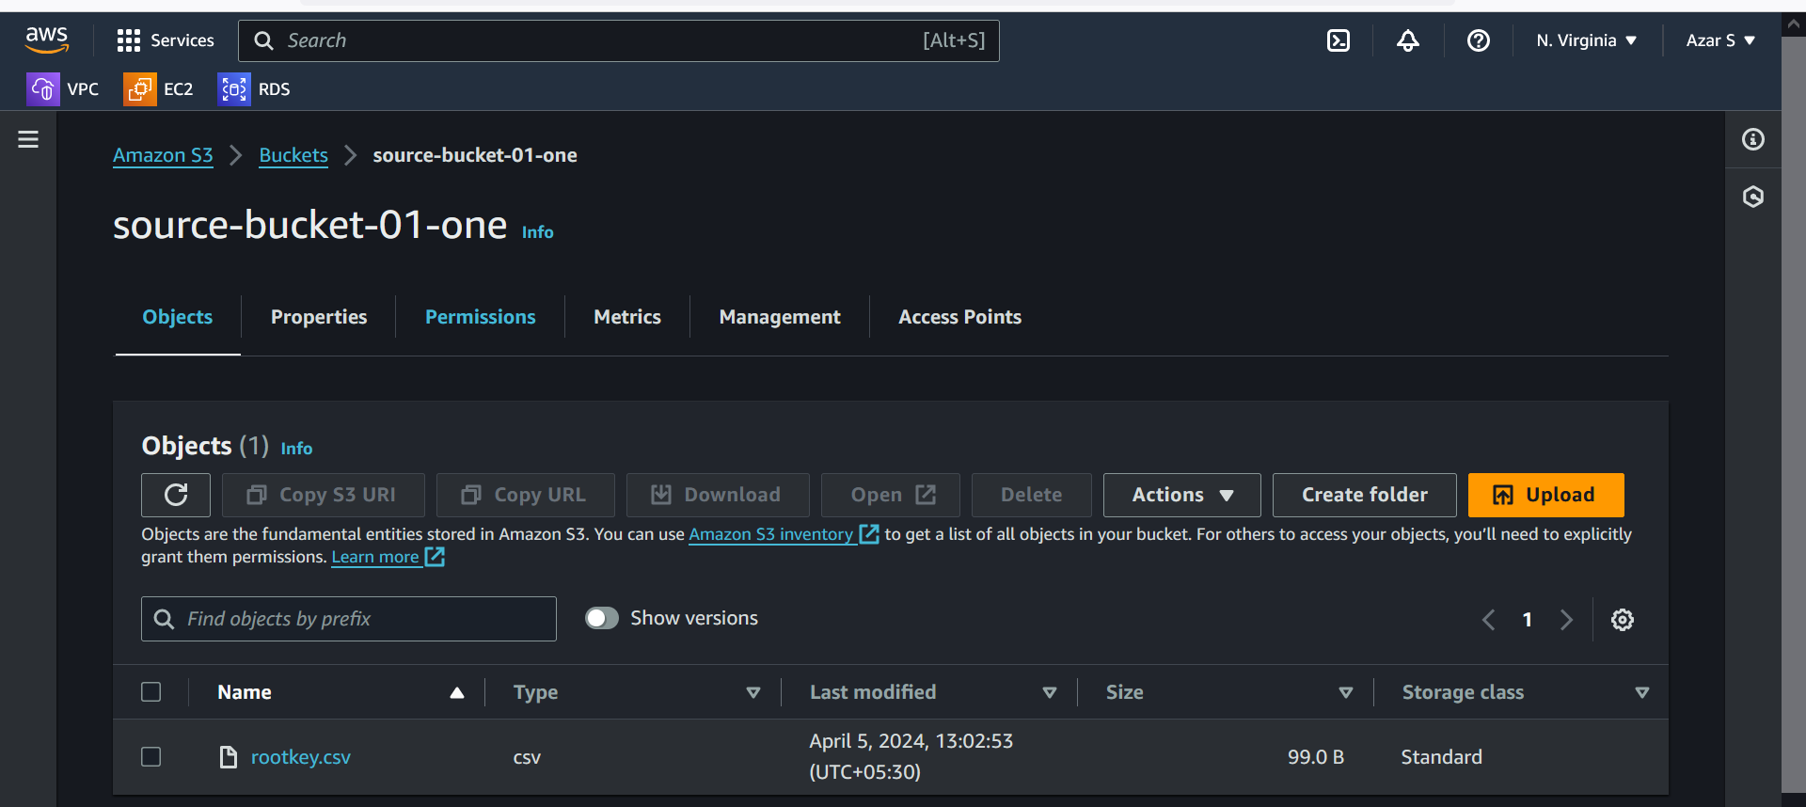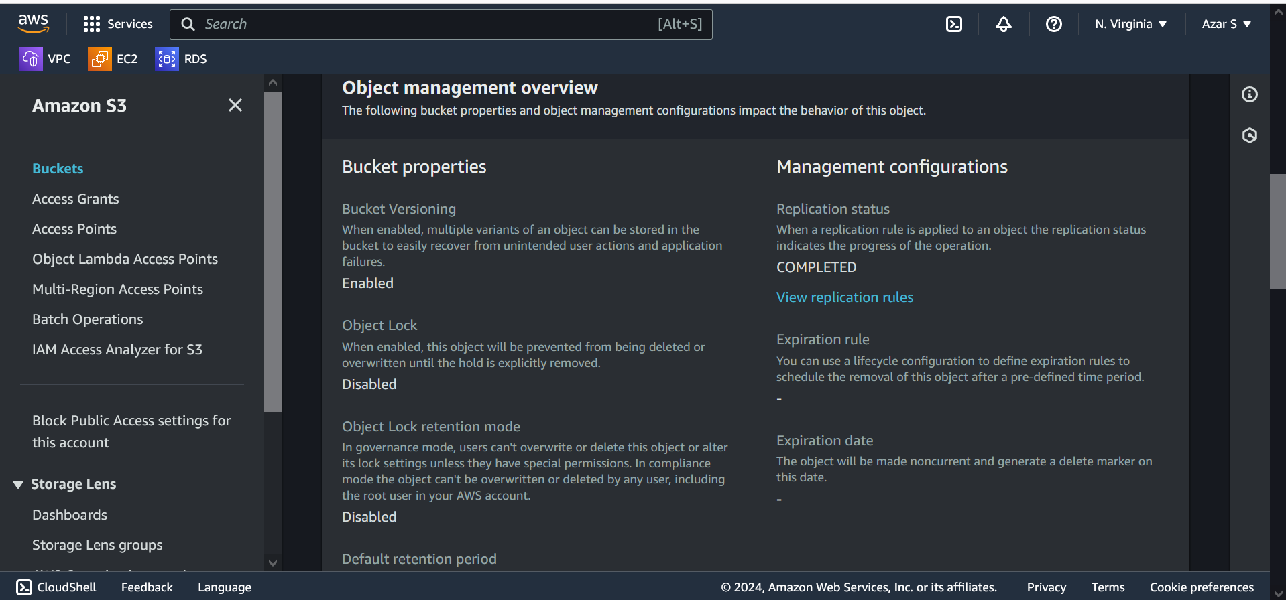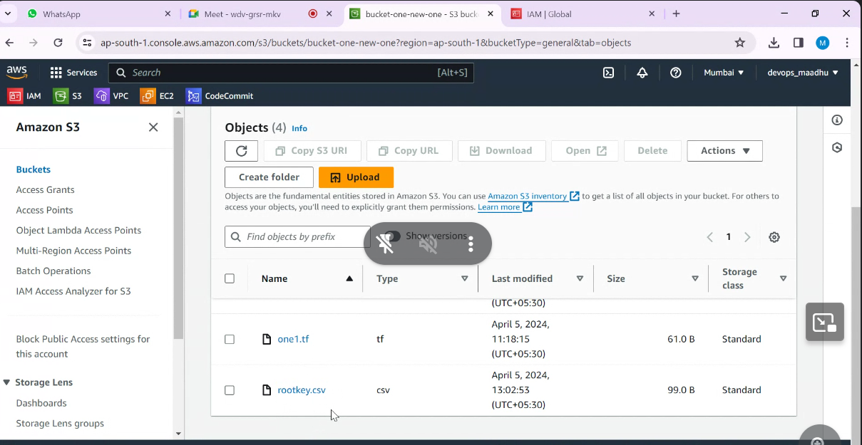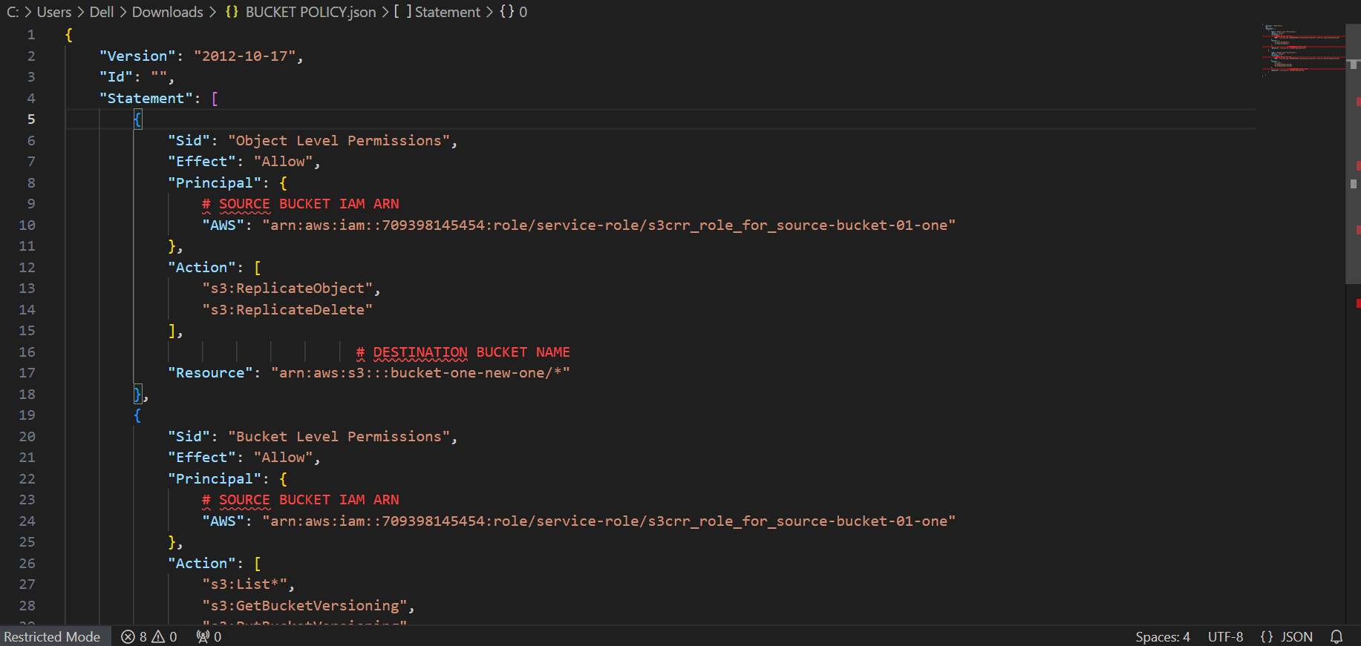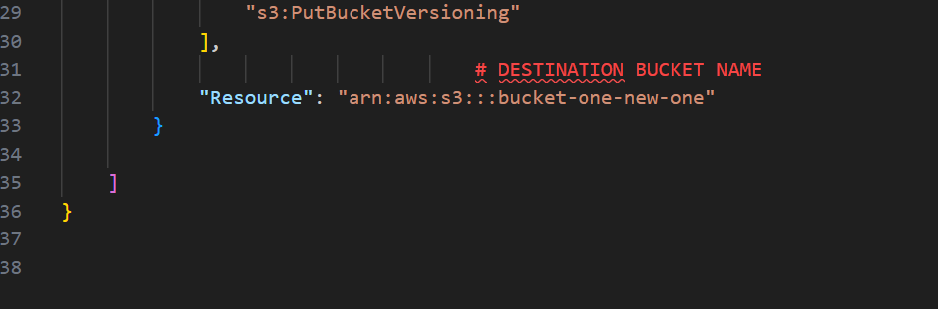

**BUCKET POLICY:**

{

"Version": "2012-10-17",

"Id": "",

"Statement": [

{

"Sid": "Object Level Permissions",

"Effect": "Allow",

"Principal": {

"AWS": "arn:aws:iam::709398145454:role/service-role/s3crr_role_for_source-bucket-01-one"

},

"Action": [

"s3:ReplicateObject",

"s3:ReplicateDelete"

],

"Resource": "arn:aws:s3:::bucket-one-new-one/*"

},

{

"Sid": "Bucket Level Permissions",

"Effect": "Allow",

"Principal": {

"AWS": "arn:aws:iam::709398145454:role/service-role/s3crr_role_for_source-bucket-01-one"

},

"Action": [

"s3:List*",

"s3:GetBucketVersioning",

"s3:PutBucketVersioning"

],

"Resource": "arn:aws:s3:::bucket-one-new-one"

}

]

}